Advanced SQL
- SQL Exercise – Advanced Concepts

Exercise 1: Ranking and Window Functions
Goal: Use ROW_NUMBER(), RANK(), DENSE_RANK(), OVER(), and PARTITION BY.
Scenario:
Find the top 3 most expensive products in each category using different ranking functions.
Steps:
1. Use ROW_NUMBER() to assign a unique rank within each category.
2. Use RANK() and DENSE_RANK() to compare how ties are handled.
3. Use PARTITION BY Category and ORDER BY Price DESC.

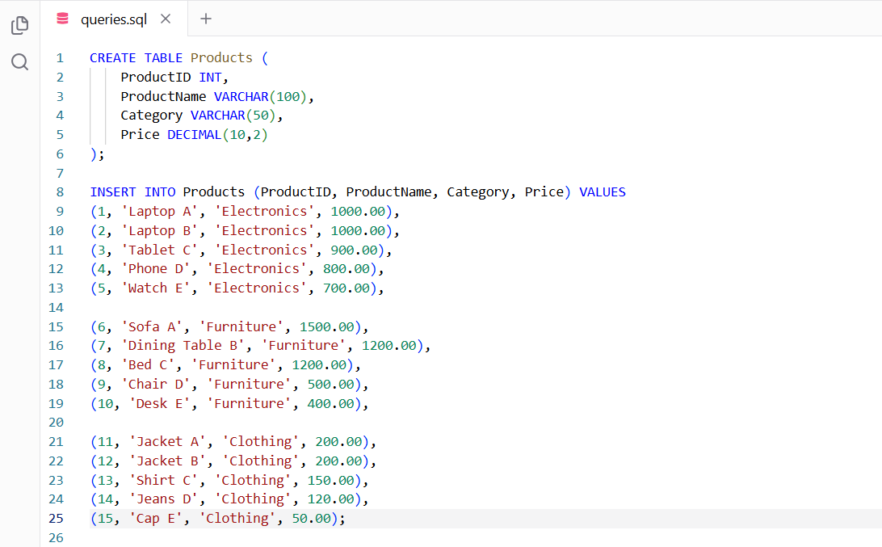
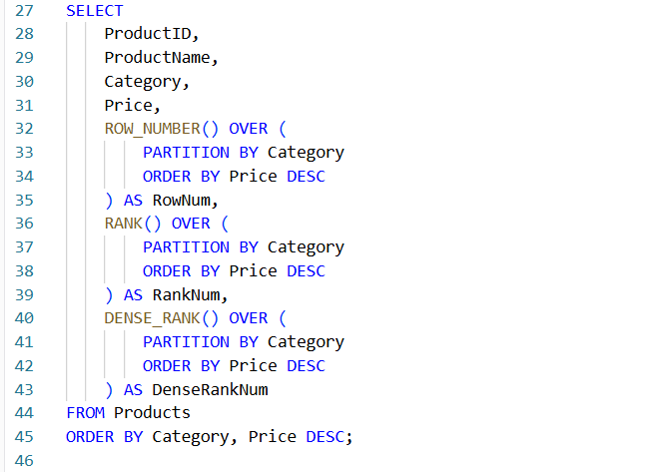

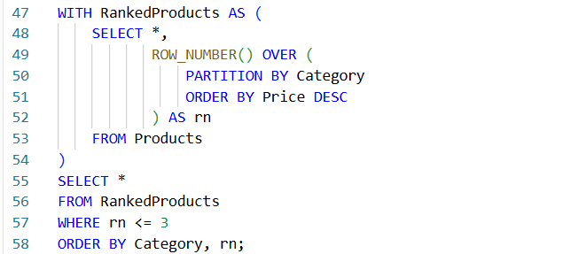
Output:
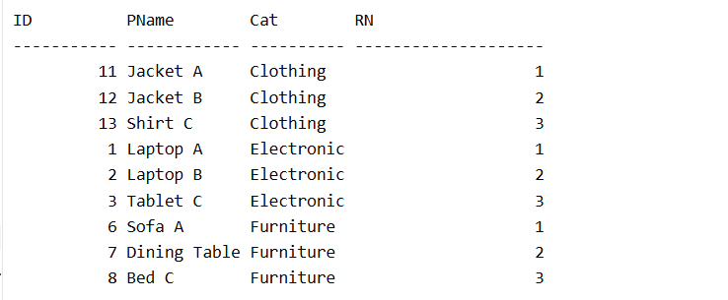
- SQL Exercise – Stored Procedure

Database Schema
The following schema defines the structure for an Employee Management System:

Departments Table

CREATE TABLE Departments (
DepartmentID INT PRIMARY KEY,
DepartmentName VARCHAR(100)
);

Employees Table

CREATE TABLE Employees (
EmployeeID INT PRIMARY KEY,
FirstName VARCHAR(50),
LastName VARCHAR(50),
DepartmentID INT FOREIGN KEY REFERENCES Departments(DepartmentID), Salary DECIMAL(10,2),
JoinDate DATE
);

Sample Data
The following sample data can be used for testing:

Departments Sample Data
INSERT INTO Departments (DepartmentID, DepartmentName) VALUES
(1, 'HR'),
(2, 'Finance'),
(3, 'IT'),
(4, 'Marketing');

Employees Sample Data INSERT INTO Employees (EmployeeID, FirstName, LastName, DepartmentID, Salary, JoinDate) VALUES
(1, 'John', 'Doe', 1, 5000.00, '2020-01-15'),
(2, 'Jane', 'Smith', 2, 6000.00, '2019-03-22'),
(3, 'Michael', 'Johnson', 3, 7000.00, '2018-07-30'),
(4, 'Emily', 'Davis', 4, 5500.00, '2021-11-05');
Exercise 1: Create a Stored Procedure
Goal: Create a stored procedure to retrieve employee details by department.
Steps:
1. Define the stored procedure with a parameter for DepartmentID.
2. Write the SQL query to select employee details based on the DepartmentID.
3. Create a stored procedure named `sp_InsertEmployee` with the following code: CREATE PROCEDURE sp_InsertEmployee
@FirstName VARCHAR(50),
@LastName VARCHAR(50),
@DepartmentID INT,
@Salary DECIMAL(10,2),
@JoinDate DATE
AS
BEGIN
INSERT INTO Employees (FirstName, LastName, DepartmentID, Salary, JoinDate) VALUES (@FirstName, @LastName, @DepartmentID, @Salary, @JoinDate);
END;

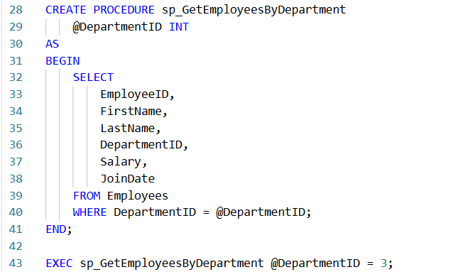
Output:
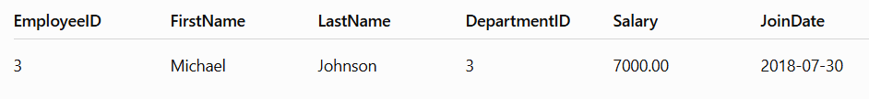
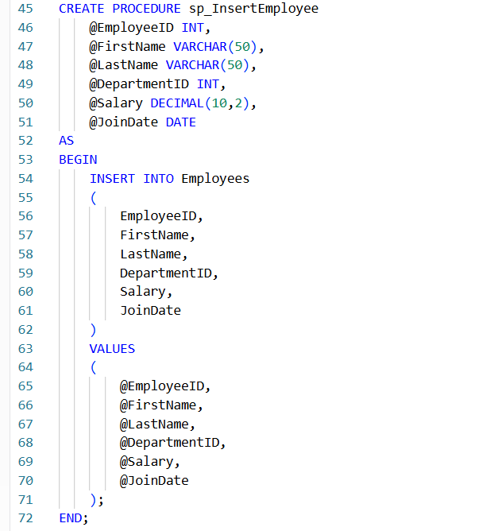
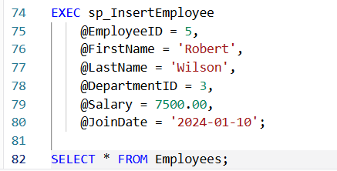
Output:
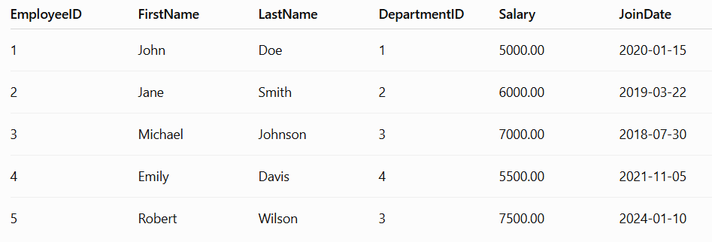

Exercise 5: Return Data from a Stored Procedure
Goal: Create a stored procedure that returns the total number of employees in a department. Steps:
1. Define the stored procedure with a parameter for DepartmentID.
2. Write the SQL query to count the number of employees in the specified department.
3. Save the stored procedure by executing the Stored procedure content.

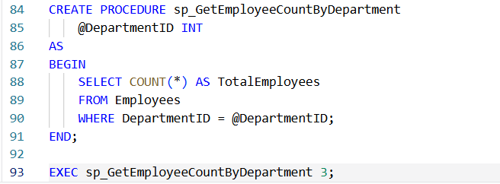
Output:
